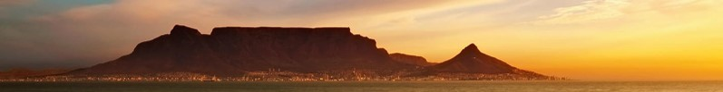
(Adapted from: https://tablemountainnational park.org)

Table Mountain
Question/Vraag 2.4

Table Mountain
Table Mountain is an iconic landmark in South Africa. It is one of the country's most photographed attractions and its famous cableway (see page Question/Vraag 2.5) has taken millions of people to its top.
Table Mountain has become the single most welcoming landmark to not only our people, but to travellers from all over the world. This mountain has many surprises awaiting to be discovered. It is much more than a scenic background from where you can take a breath-taking photo of the city of Cape Town.
The flat top peak of the mountain reaches 1 086 m above sea level, but being so close to the sea and to the city its features look more imposing. There are about 2 200 species of plants found on Table Mountain and 1 470 floral species. Many of these plants and flowers are endemic to this mountain.
The magnificent Kirstenbosch Garden is found on the eastern foothills of the mountain. Founded in 1913, the gardens span an area of 1 300 acres and includes a unique conservatory with plants from different parts of the world. The whole area surrounding the mountain has a biodiversity that is rare to find in other places. The mountain area has many valleys and streams that make it an idyllic getaway from the city of Cape Town.
The Table Mountain National Park's most unique feature is its fynbos vegetation, one of the richest floral regions in the world. Over 70% of the flowers are endemic to the Table Mountain. It is no wonder that the mountain was chosen as one of the new seven wonders of the world.
Although animals such as the cape lion, mountain zebra or leopard are no longer found here, the park is still home to caracals, rock hyraxes or chacma baboons. The African penguins flock all over the rocks to Boulders Beach – a unique sight in Africa.
Besides the Table Mountain, Cape Town contains another one of South Africa's attractions, the Cape of Good Hope, the most southern point of the African continent.

History
The Khoi and San people named the mountain Hoerikwaggo or Mountain of the Sea. But the history of this mountain dates back to more than 30 000 years ago. There is some evidence that the mountain was inhabited in the Stone Age, as hand axes were found in the Kirstenbosch Garden.
The mountain was held sacred by the Khoi and San people as they believed their god (Tsui or Goab) lived there.
The first European to see the Cape was Bartholomew Dias in 1448. In 1497, Vasco da Gama reported seeing it as well.
The first recorded climb of the mountain was undertaken by the Portuguese navigator, Admiral Antonio de Saldanha, in 1503. It was de Saldanha who gave the mountain its name, Taboa da Caba, meaning Table of the Cape. Since then, many people from all around the world have climbed the mountain.
The cable car opened in 1929 making reaching the summit easier than ever before. More than 22 million people have used the cable car which was renovated and re-opened in 1997.
The mountain gained natural park status in 1998. In 2004 the Cape Floristic Region was declared a UNESCO World Heritage Site.

Hiking
The Table Mountain National Park has popular hiking trails with the most beautiful scenery. There are over 350 trails that lead to the top of the mountain. It caters for all types of hikers, from casual strollers to the more experienced ones.
The easier trails include Constantiaberg, Silvermine or the Cape of Good Hope, while the more difficult trails are Platteklip Gorge, Nursery Ravine and Skeleton Gorge.
Hiking the Table Mountain National Park is mostly free with the exception of some areas where conservation fees have to be paid like, at the Kirstenbosch Garden, Cape Point or Boulders Beach.
Its close proximity to the city makes many people feel safe in the park, However, the area is wild and climbing it can be especially dangerous. Many hiking trails commence from Camps Bay.
The Table Mountain National Park is very well marked but if you are inexperienced you may want to hike with a group.

Free Walking Guides
There are enthusiastic volunteers who offer free guided walks on the second Sunday of each month. The meeting point is at the main gate. All hikers should wear strong boots, and carry a hat, sunscreen, water, raincoat and a snack.
A 'Wild card' giving entrance to all parks can be obtained from the Tourism Sales Office at 021 528 9563 (closed daily between 12:30 – 13:00).
Enquiries at John: 082 742 4289 or Ian: 066 942 3584.

Facts
- The History:
  - Table Mountain is the only South African and only natural site on this planet to have a constellation of stars named after it. The constellation is called 'Mensa' which means 'table' in Latin.
  - The mountain is now officially recognized as one of the seven wonders of the world.
  - Table Mountain is often covered in cloud which is referred to as its 'table cloth'.
  - It is South Africa's most photographed landmark.
- The Land:
  - Table Mountain is featured on Cape Town's flag.
  - There are many caves on Table Mountain and the biggest one is Wynberg.
  - The rocks on the mountain are over 600 000 000 years old, making Table Mountain one of the oldest mountains in the world.
  - More than 70% of all the plants found on the mountain are endemic, meaning they are not found anywhere else.
  - Having withstood 6 million years of erosion, it hosts the richest floral kingdom on earth, with more than 1 470 floral species.
- The People:
  - Over 800 000 people visit it each year.
  - The Khoi people used to call the mountain Hoerikwaggo (Mountain of the Sea).
  - The first European to climb the mountain, Antonio de Saldanha, called it Taboa da Caba (Table of the Cape).

Access
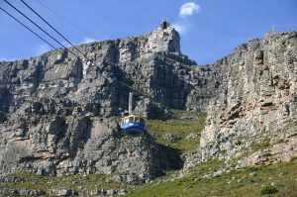
There are many ways to get up to the top of Table Mountain.
Cableway
The most popular way up to the top of the mountain is to use the cable car which has transported visitors since 1929. There are various areas of the Table Mountain National Park where one has to pay entry fees, for example to: Boulders Beach, Silvermine, Cape Hope, Oudekraal, Tokai picnic site, etc.
Some parts of Table Mountain are not yet connected by bus; so, if you wish to see all of them in a day, your best option is to do it by car.
Access routes to the Table Mountain National Park are:

Boulders Beach is located in Simon's Town, on the M4 freeway. Alternatively, you can go to Muizenberg via the M3 and M5 and from there continue to the M4.
Kirstenbosch Garden is closer to the city centre, less than 20 minutes with no traffic. Getting there is best travelled via the M3 and M63.
Oudekraal is located on the M6 route between Camps Bay and Llandudno.
Cape Point is naturally the furthest destination from the city centre as it is the southernmost point of the continent. One can reach it either via the M4, passing through Simon's Town or by using the M3, M64, M6 and M4 routes.
Table Mountain National Park Map
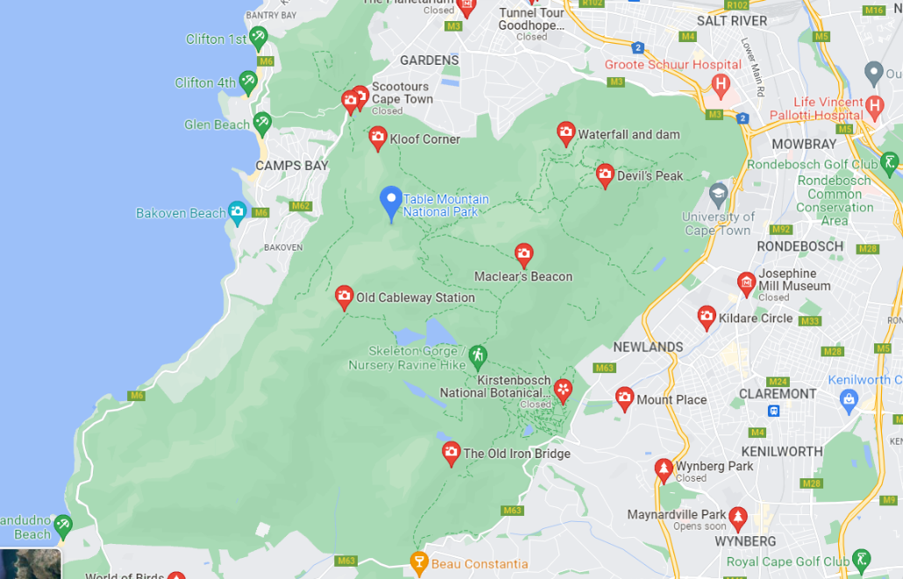

Cableway Ticket Sales
Using the cable car is by far the fastest and easiest way of reaching the summit of the mountain.
The best option to get to the cable car station is to take the bus, because parking is limited. There is a bus station at Kloof Nek Road.
Cable Car Tickets and Hours

Tickets include:
- 1-day access to the hop-on-hop-off buses
- Multilingual audio guide/Walking tour guide
- Table Mountain aerial view
- Cableway return ticket

